**Lab: 3  
Understanding Working of HTTP Headers**

**Question:** Understand working of HTTP headers Conditional Get: If-Modified-Since

HTTP Cookies: Cookie and Set-Cookie

Authentication: Auth-Basic

Design a web page that has one embedded page (e.g. image) and sets a cookie and enables authentication. You are required to configure the web server (e.g. apache) with authentication mechanism. Show the behavior of conditional get when embedded objects are modified and when it is not (you can just change the create date of the embedded object). Decode the BasicAuth header using Base64 mechanism as per the password setup.

**Observation**: Show the behavior of browser when cookie is set and when cookie is removed. **Solution:** Analyzing Basic Authentication and Cookies

The three parts of experiment are: 1. Password Authentication 2. Cookie Setting  
3. Conditional get

**Steps of Execution (for Password Authentication)** 1. Executing the below commands on the terminal.

--> Provide username and password to set authentication

**sudo htpasswd -c /etc/apache2/.htpasswd netwo**

--> View the authentication

**sudo cat /etc/apache2/.htpasswd**

Here “netwo” is the username. Also, password is entered twice.

2. To setup the authentication phase, execute the following commands. Configuring Access control within the Virtual Host Definition.

--> Opening the file for setting authentication

**sudo nano /etc/apache2/sites-available/000-default.conf**

<VirtualHost*:80>  
ServerAdmin webmaster@localhost  
DocumentRoot /var/www/html  
ErrorLog ${APACHE_LOG_DIR}/error.log  
CustomLog ${APACHE_LOG_DIR}/access.log combined <Directory "/var/www/html">

AuthType Basic  
AuthName "RESTRICTED" AuthUserFile /etc/apache2/.htpasswd Require valid-user >

</Directory> </VirtualHost>

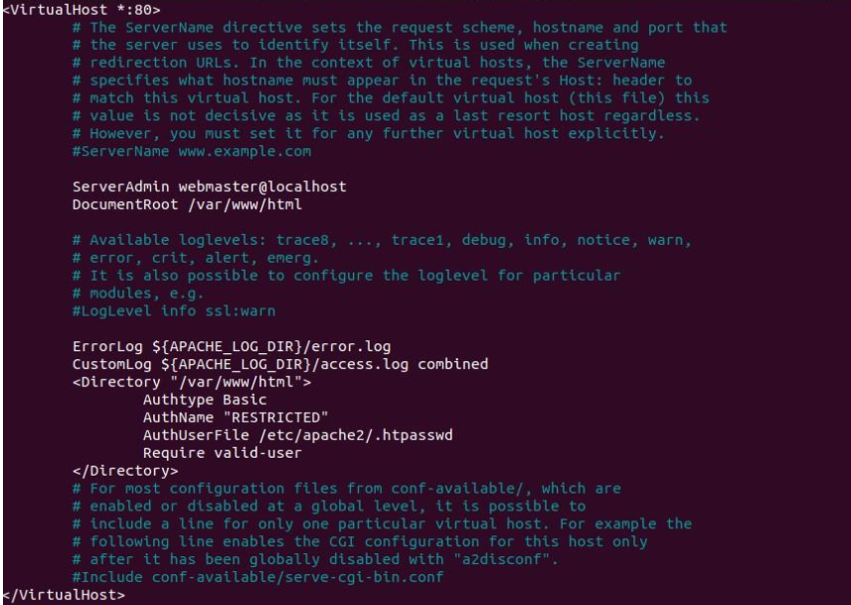

3. Password policy implementation is done by restarting the server as:

**sudo service apache2 restart**

4. The localhost is then accessed using the Firefox browser requiring a username and a password set during the authentication phase.

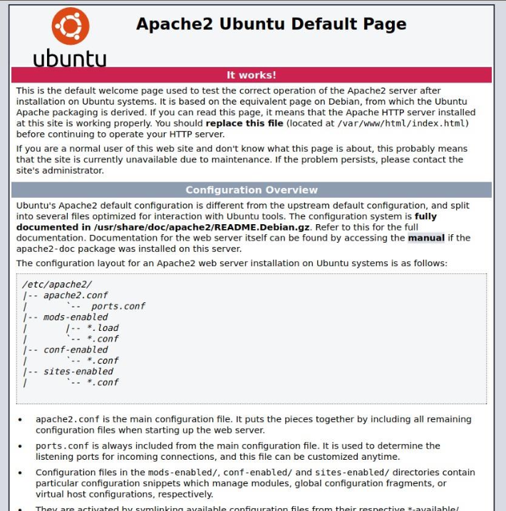

5. Wireshark is used to capture the packets sent upon the network. 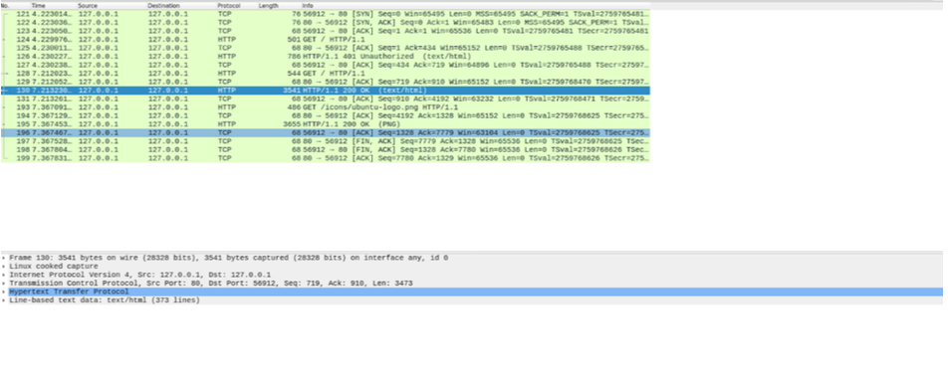

6. Using the “follow TCP stream” on the HTTP message segment the password was retrieved which was encrypted by the base64 algorithm and decryption could be done with same algorithm.

**Steps of Execution (Cookie Setting)**

1. A PHP file to set the cookie is created which also contains an image in it (placed under the HTML directory) to be accessed once the cookie is set. The following code helped to set the cookie:

<html> <?php

setcookie("namecookie","netqwerty",time()+123); setcookie("nickname","work"); ?>

<img src= “highres.png” width= “300” height= “300” title= “password” /> </html>

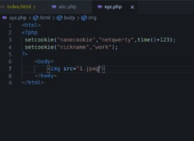

Note: The Image added is called **1.jpeg**2. The combined file saved with a .php extension is placed under **/var/www/html** for accessing.





3. The packets are captured using Wireshark and using the “follow TCP stream” which checks for the set-cookie field whether the cookie is set or not set.

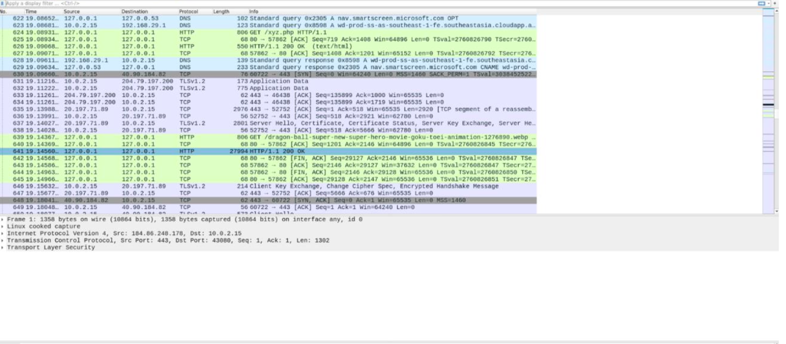

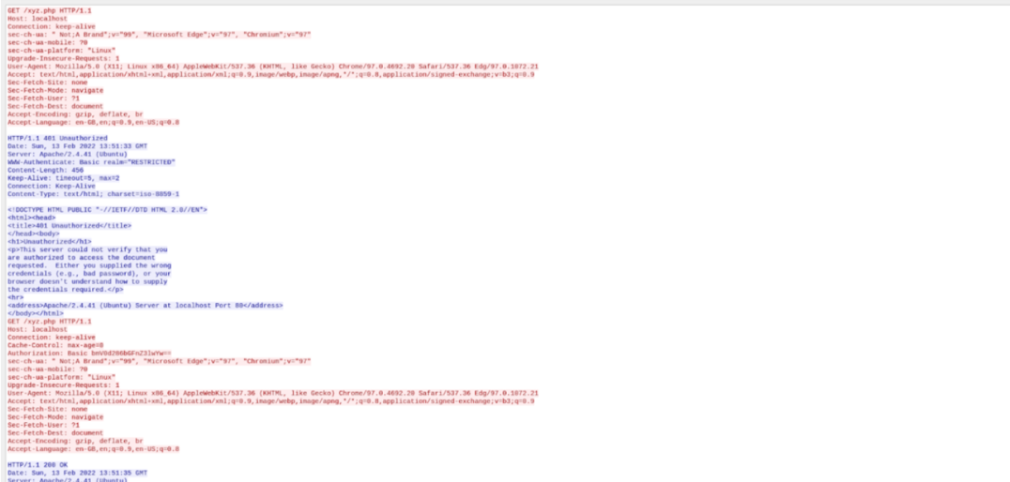

The cookie is set as shown in the above screenshot.

**Observation:** Understand and work out base 64 algorithm and write in your observation. Observe various parameters associated with Cookie in the wireshark capture. **Conditional Get: If-Modified-Since Observations:**

1. Inspect the contents of the first HTTP GET request from your browser to the server. Do you see an “IF-MODIFIED-SINCE” line in the HTTP GET?
2. Inspect the contents of the server response. Did the server explicitly return the contents of the file? How can you tell?
3. Now inspect the contents of the second HTTP GET request from your browser to the server. Do you see an “IF-MODIFIED-SINCE:” line in the HTTP GET? If so, what information follows the “IF-MODIFIED-SINCE:” header?
4. What is the HTTP status code and phrase returned from the server in response to this second HTTP GET? Did the server explicitly return the contents of the file? Explain. Wireshark containing the HTTP REQUESTS AND RESPONSES

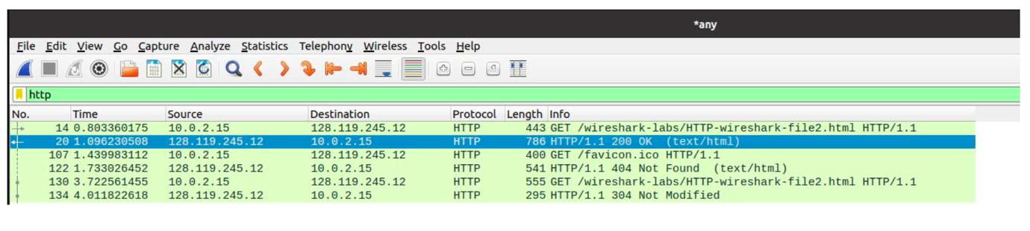

1. IF-MODIFIED-SINCE is not present in the first HTTP GET

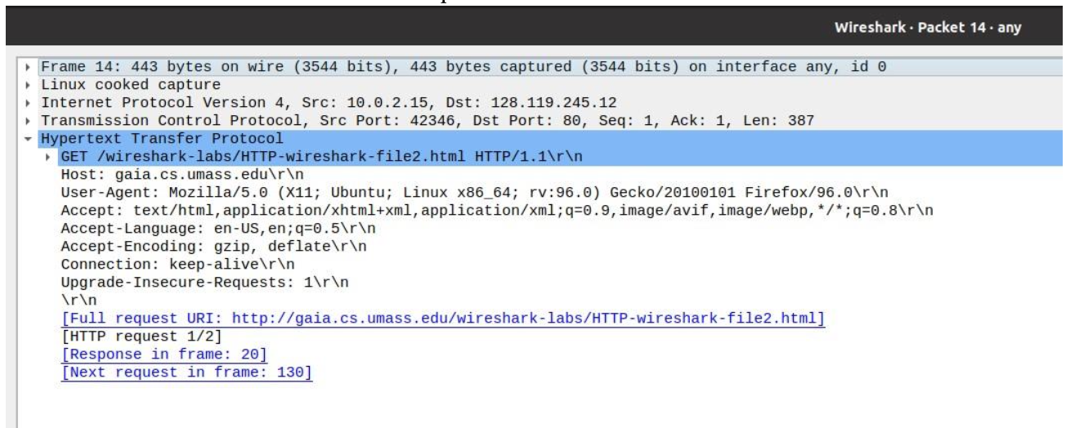

2. The server explicitly returned the contents on the first HTTP RESPONSE  
**Line-Based text data** is the content returned by the **server** on **first HTTP RESPONSE**

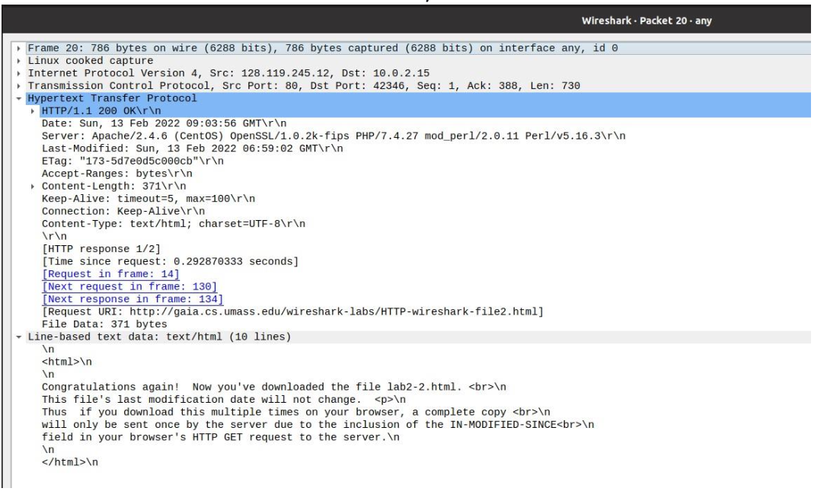

3. Yes. IF-MODIFIED-SINCE is present in the second HTTP GET

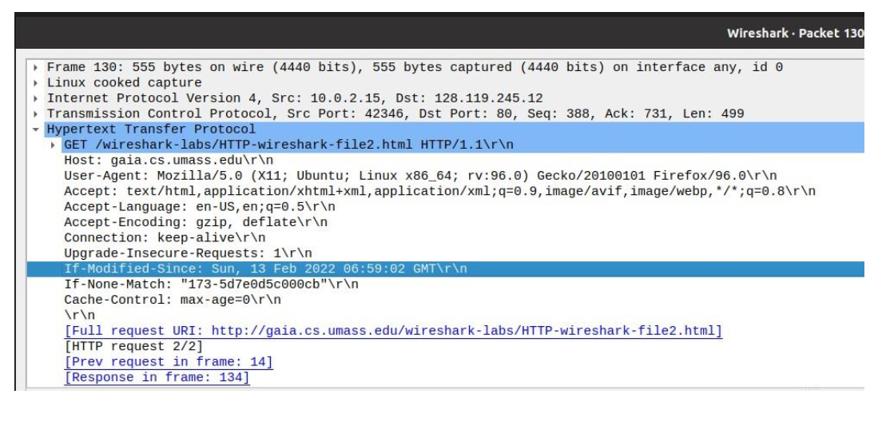

4. The HTTP status code for the second HTTP GET is **304.**The Server does not return the file as they are already present from the time the first http get request was made.This time the contents are not modified.

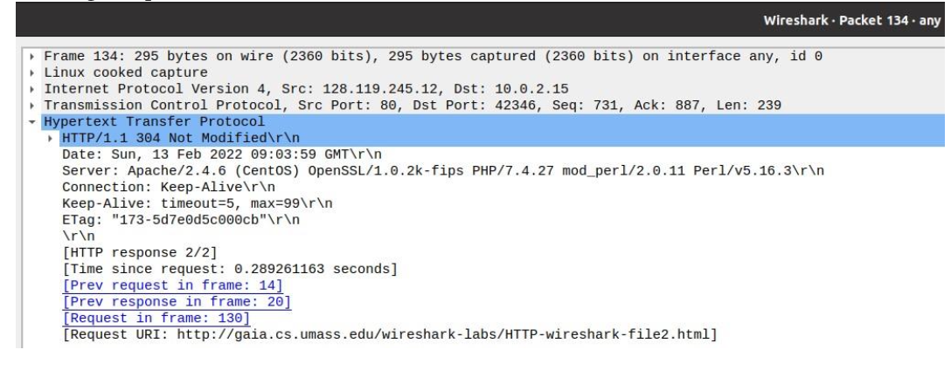

**For a server with images (used the website www.zoomify.com)**

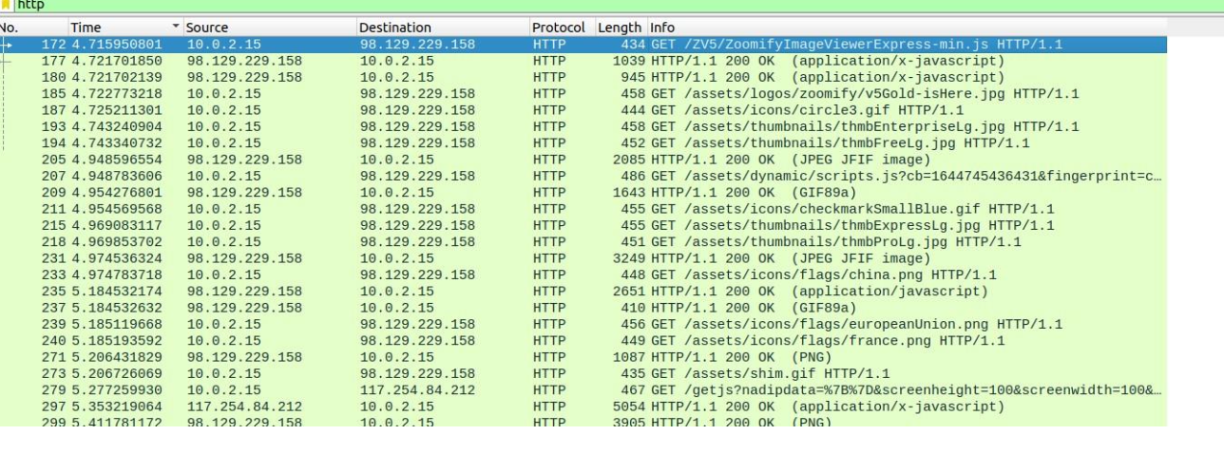

1. IF-MODIFIED-SINCE is not present in the first HTTP GET

2. Theserverreturnsthefileexplicitly.

3. Yes. IF-MODIFIED-SINCE is present in the second HTTP GET

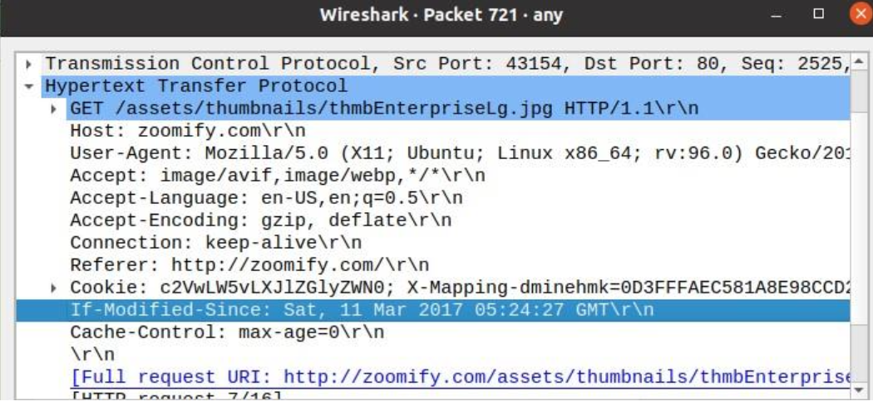

4. The HTTP status code for the second HTTP GET is **304.**The Server does not return the file as they are already present from the time the first http get request was made.

**Persistent Non-persistent Connections**

Non- Persistent

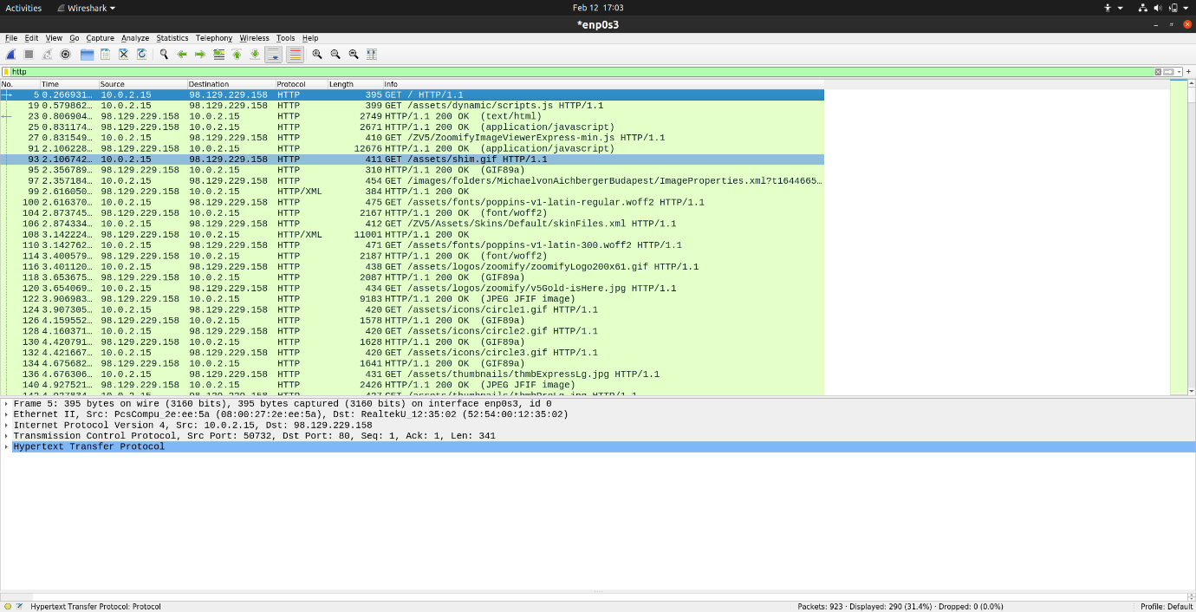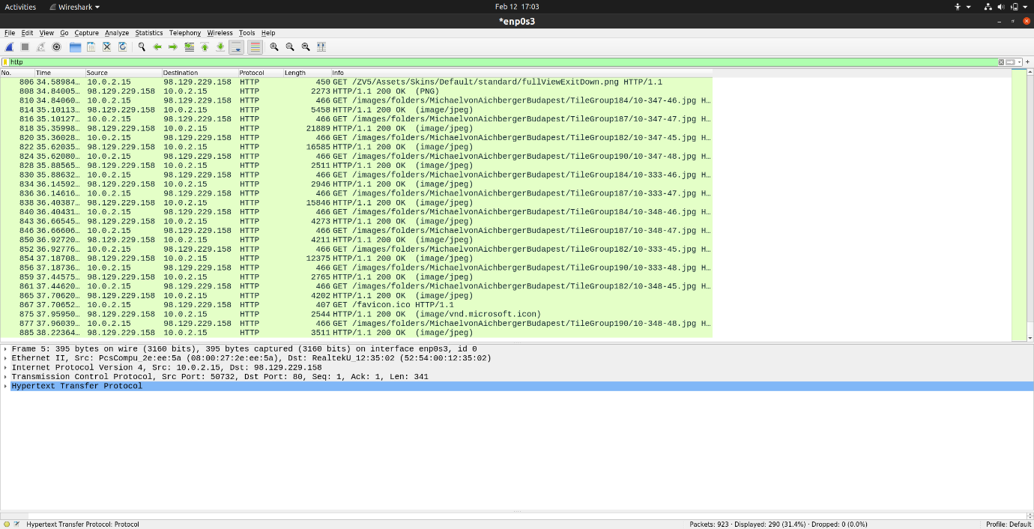

38.2236-0.2669=37.9567

Max Number of persistent Connections 2

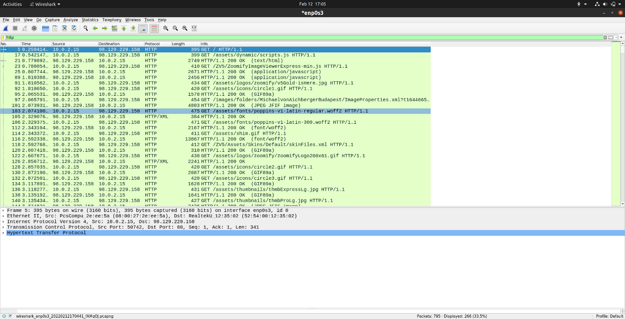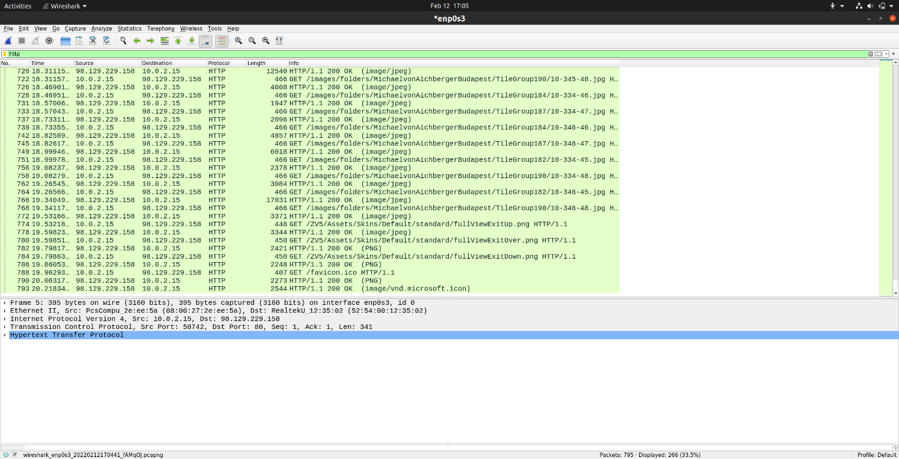

20.238-0.2594=19.9786

Max Number of persistent Connections 4

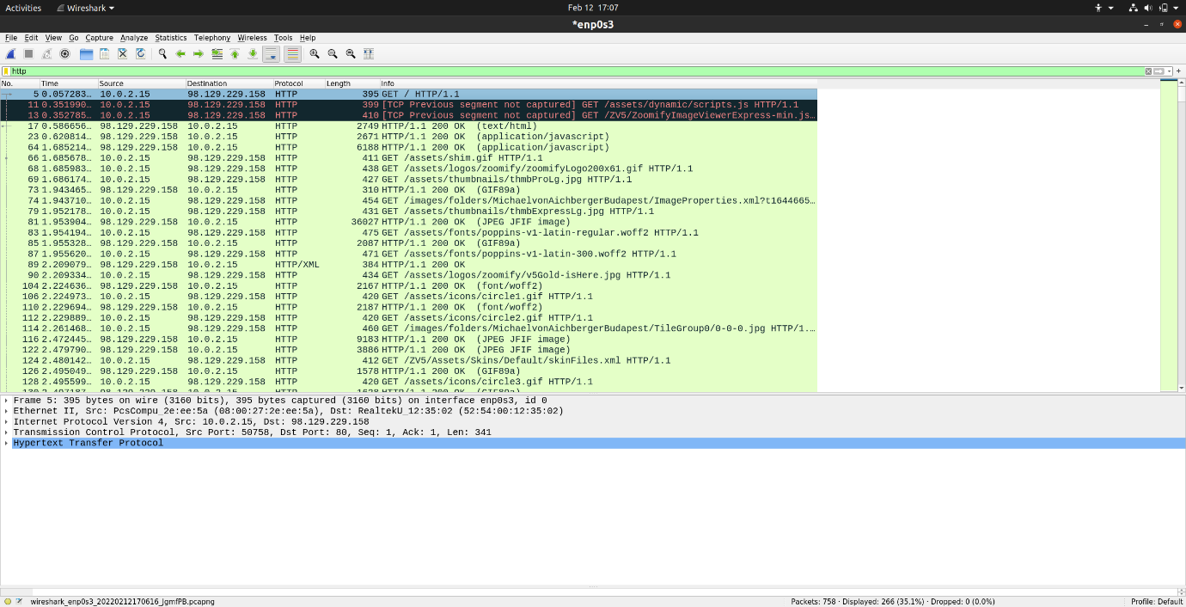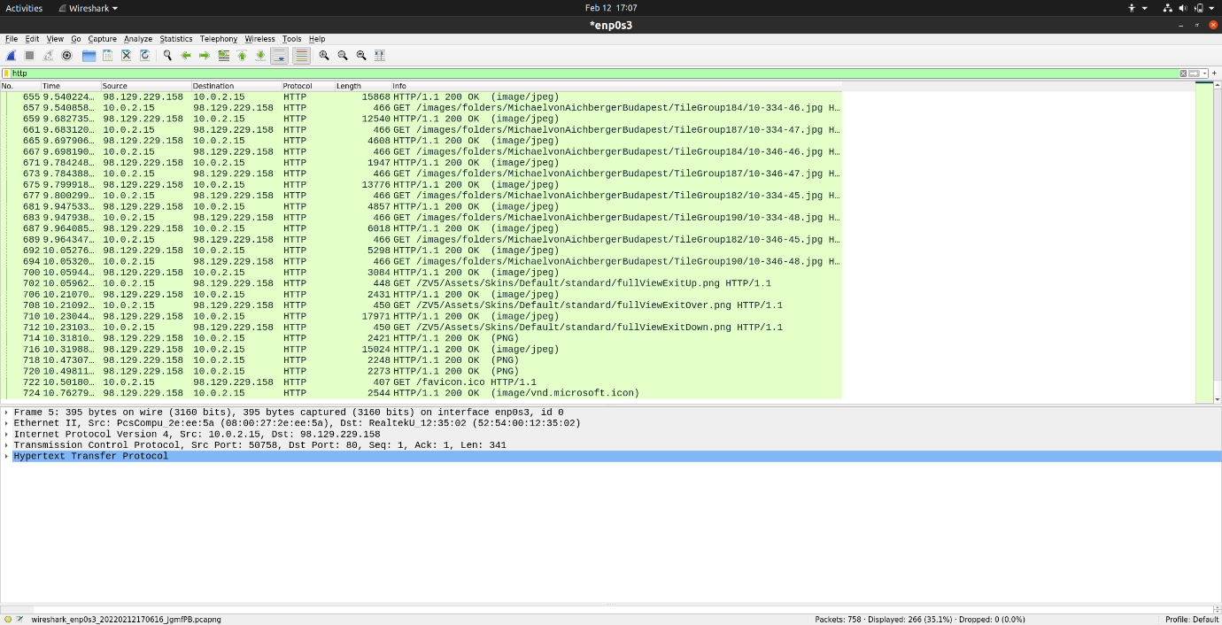

10.762-0.057=10.705

Max Number of persistent Connections 6

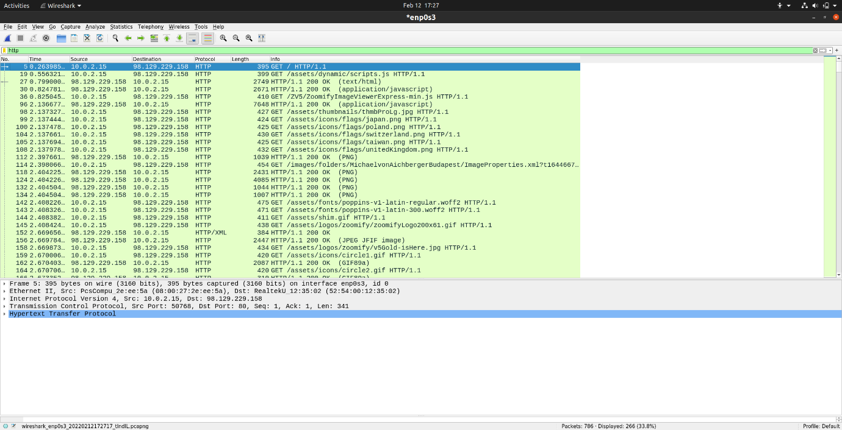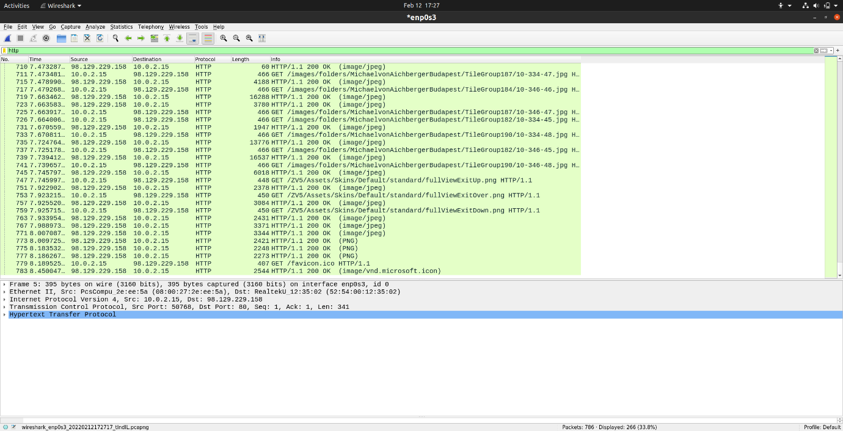

8.45-0.263=8.187

Max Number of persistent Connections 8

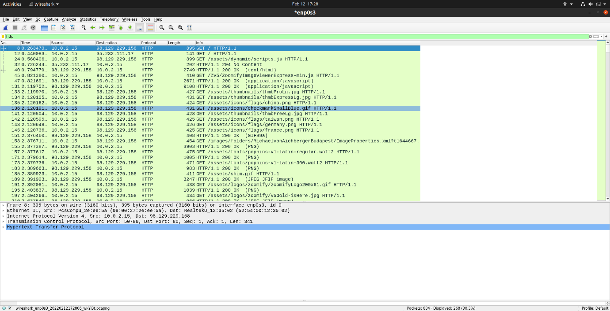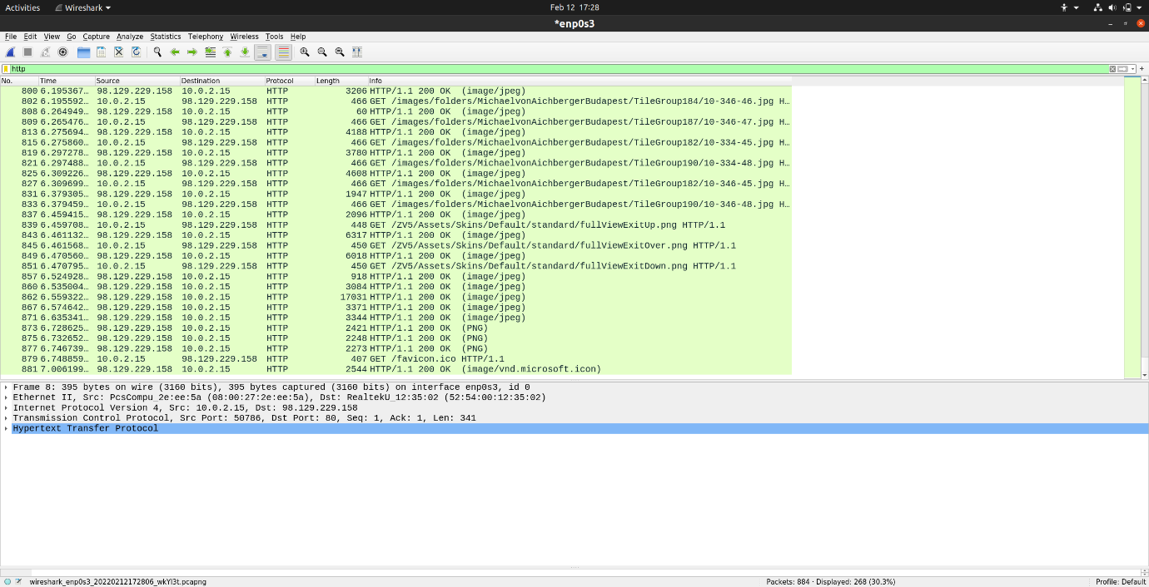

7.006-0.263=6.743

Max Number of persistent Connections 10

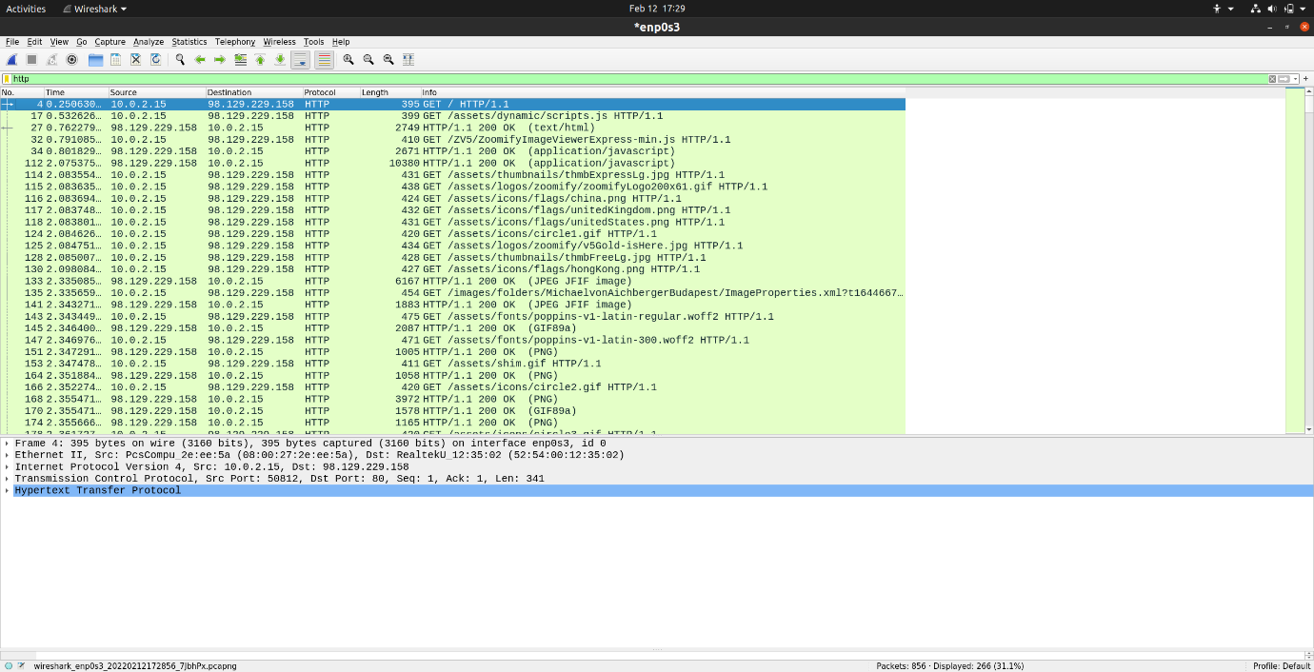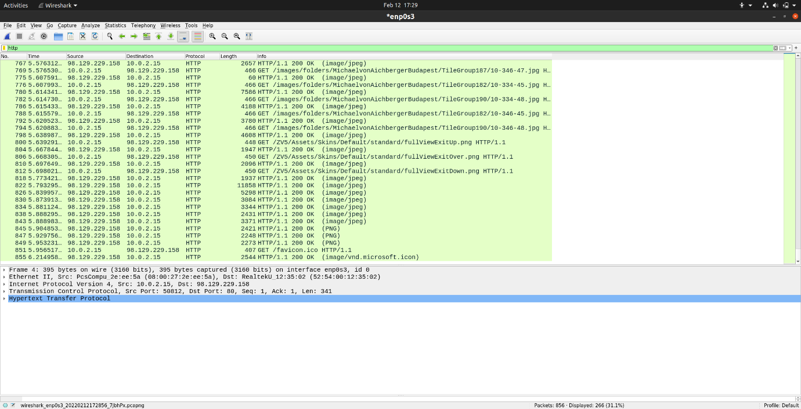

6.214-0.250=5.964